# London & Hogwarts Adventures

We had a fabulous 4 days in London together recently. The end turned out to be a disaster, but that is not what I will remember the most. We saw the city from 443 feet up in the air, we found several red telephone booths, we visited Buckingham Palace, we spent time in a royal children's museum, we toured the Warner Bros. Studio - where all the Harry Potter movies were filmed, we ate some fish & chips, and we visited a few family history sites together.

Saturday, Oct. 14th:

Scott drove us to the Venice Airport, where we had a successful flight on RyanAir to the London Stansted Airport. I had never heard of this airport before, but it turned out to be a pretty good sized airport north of London.

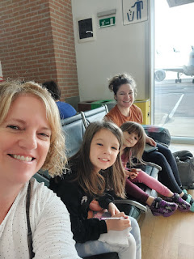

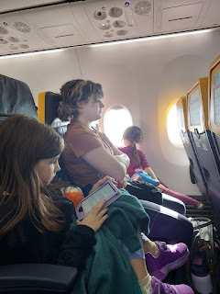

We rode the Stansted Express train south toward London, changed trains once, and then walked 0.4 miles to our hotel. It took a little over an hour to get there from the airport. St. Athans Hotel is in a 200 year old building in the Bloomsbury district of London, and is full of quirky features like narrow circular staircases, leaning walls, lots of tiny rooms, etc. We had a room on the 2nd floor that housed a double bed (for Amber & Weston), a single bed (for me), and a bunk bed (for the girls). Yes, all 5 of us stayed in one room . . .  with access to 2 shared bathrooms a half floor down. It was a tight squeeze, but it was the cheapest option for all of us to stay together in London because it is an EXPENSIVE city. Other options were to get TWO rooms or to get an AirBnB, but both of those were way too pricey.  So we made do. :)

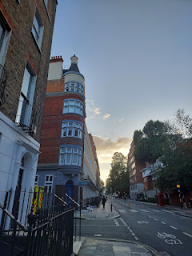

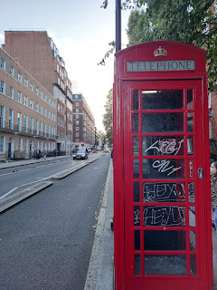

After a bite to eat around the corner, we hopped on a bus to head down to the Thames River.

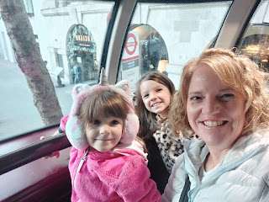

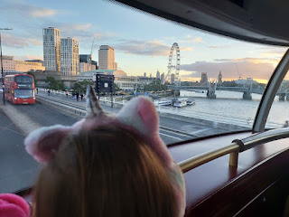

We had tickets to ride the London Eye . . .

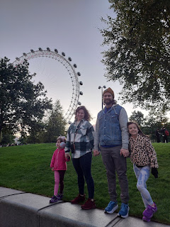

As we got close to the River, there was a guy playing his guitar and singing his heart out. I could have stayed and listened to him for a long time . . .    he was really good.

Video of him singing: (26 seconds)

https://photos.app.goo.gl/w35sKGVEFyqL4NBo9

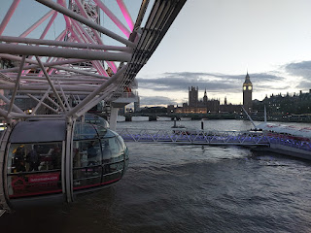

The London Eye was even bigger than I thought it would be . . . we bought flexi-pass tickets, which were more expensive but it allowed us 2 things: we could ride whenever we wanted without a scheduled time and we could skip the line. This turned out to be such a blessing because Weston arrived to London very jet-lagged from Louisiana, and it was also verrrry chilly in London. The girls were cold and could have used one more layer while we were out and about . . .

The whole experience lasted about one hour and it was absolutely magical. We watched the sun setting over the Thames River and then the whole city came alive with lights.

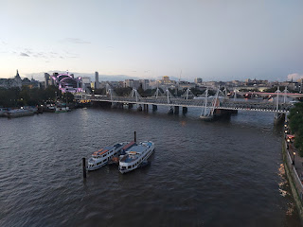

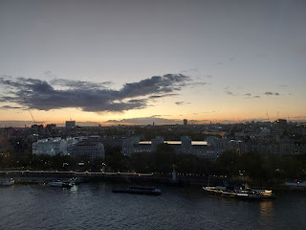

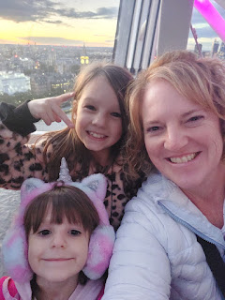

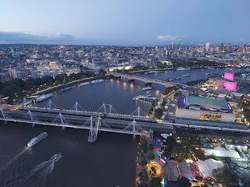

The views from each side of the big bubble that we were tucked into were just spectacular.

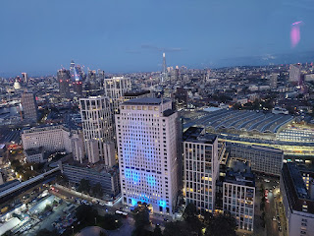

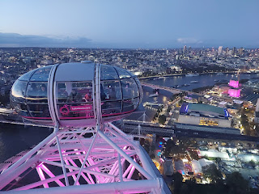

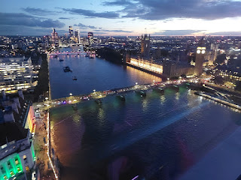

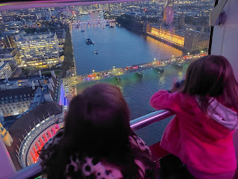

Video looking down below: (10 seconds)

https://photos.app.goo.gl/TMeCu7momdvV3AB79

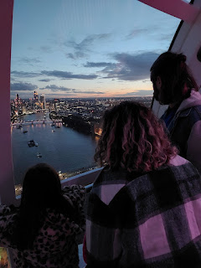

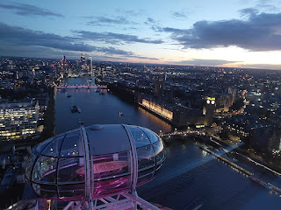

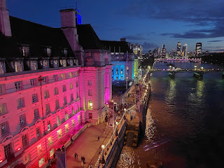

Me and Big Ben across the River Thames . . .

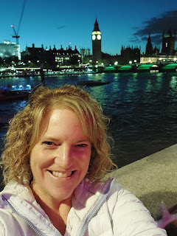

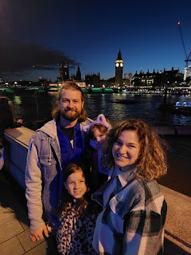

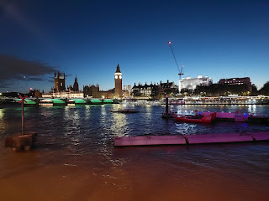

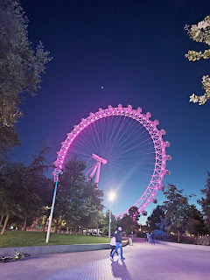

We walked to a nearby bus stop and made our way back to the hotel so Weston could drop off into the Land of Deep Sleep for the night. I walked to a little grocery store to pick up a few things so we could have some fresh fruit and a little bite to eat for breakfast that didn't require any refrigeration.

I was tempted to buy some cans of this . . . (ha ha just kidding) . . .



Sunday, October 15th:

We had planned on attending church that morning, but then logistics got in the way. We hadn't realized that our one opportunity to see the changing of the guard at Buckingham Palace was at the same time as church, but in the opposite direction! Normally I do place church over anything else, but I laid out the information to our family group and we all decided to head toward Buckingham Palace for the morning. My hope was that we could find ways to feel connected to God and Jesus Christ throughout the day. I also made a silent promise to my Father in Heaven during my morning prayer that I would not spend money on anything extra that day, except for food. I thought that was one small way I could honor the Sabbath Day . . .

The walk to the Underground had some traditional row houses on either side of the road.

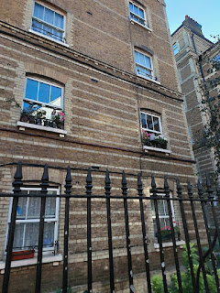

And when we rode the lift down to the train platforms, there was a very nice lady with a very fluffy white dog that rode down with us. Gwen loved how soft he was.

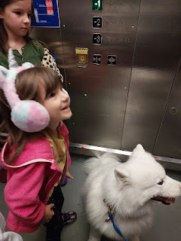

We walked through Green Park on our way to the Victoria Memorial area. It was lush and lovely.

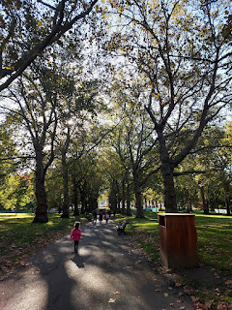

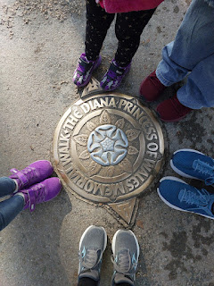

I loved seeing all the memorials and a quiet devotion to the former Princess Diana of Wales in many areas around London, especially in Green Park, which is so close to Buckingham Palace.

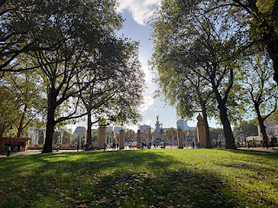

We had planned to find a viewing spot at the Victoria Memorial, since that was highly recommended in my online research. But, even though we got there about 45 minutes ahead of schedule, it was already packed with spectators!

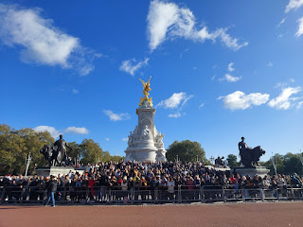

A selfie in front of Buckingham Palace . . .

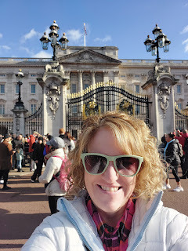

And directly across from the gates of Buckingham, is the Victoria Memorial . . .

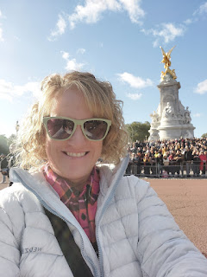

We found a little corner to commandeer, and could hear the procession coming well before we could see them. But finally, the marching band came in through one of the gates and we could actually see them.

Video of the Old Guard and band marching into the south gate: (12 seconds)

https://photos.app.goo.gl/P3LTHdB7jmaMDgk9A

There is a lot of pomp and circumstance in the changing of the guard, but from what I read online, it's basically the New Guard coming to swap out the Old Guard. It involves a few inspections and a symbolic handing over of the Palace key to the New Head Guard, etc. But that's the essence of what happens.

Video of the New Guard coming in thorugh the north gate, closest to us: (39 seconds)

https://photos.app.goo.gl/VxFCga22cqY9B5jZ7

More marching and music: (14 seconds)

https://photos.app.goo.gl/hLWJ7mKgpS3h1egB6

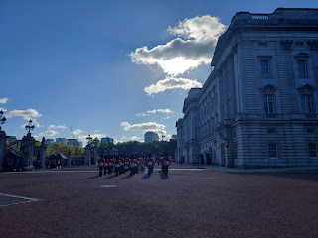

Gwen had a hard time being patient through the lengthy process, so Amber began giving her some math problems to solve in her head. That always seems to work well with her, ha ha.

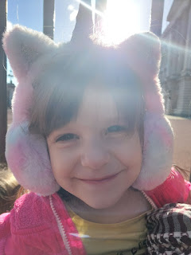

After the event was all done, we made our way from the Palace (seen in the background behind Gwen and Abby below) over to St. James' Park.

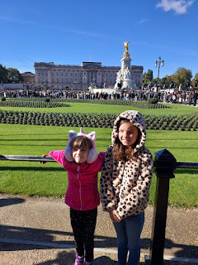

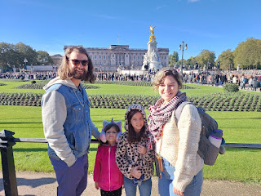

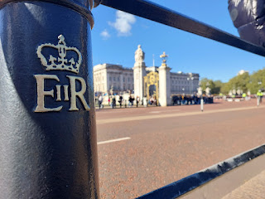

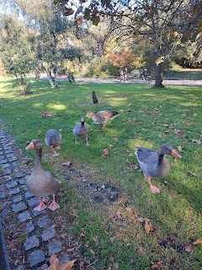

St. James' Park has trails and green space, as well as lakes and geese and bridges with lovely views in both directions. The Blue Bridge allows you to see the London Eye and Big Ben in one direction, and Buckingham Palace in the other direction.

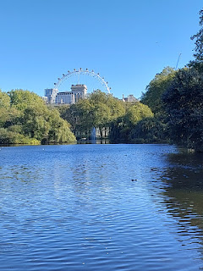

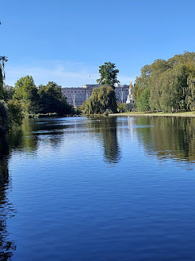

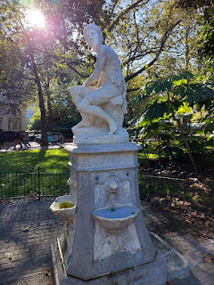

We let the girls play at the St. James' Playground for a really long time, which was so great for them after they had to be so patient during the lengthy changing of the guard. They had a wonderful time while the grownups sat on a bench and chatted.

Then we made our way through the rest of the Park and over to the Underground Station. London is very clean for being such a large city. I enjoyed the different neighborhoods and the architecture and charm of each one.

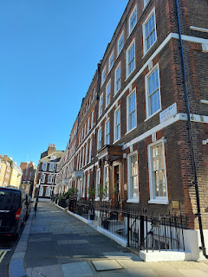

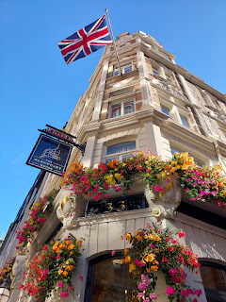

We walked past Westminster Abbey but did not go inside. We had to be choosey because of the limited amount of time that we had in London, but also keeping the kids in mind. We aimed to have a variety each day for them to see and enjoy.

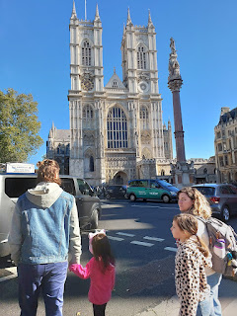

We were close to Big Ben in this neighborhood, too . . .

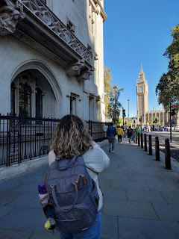

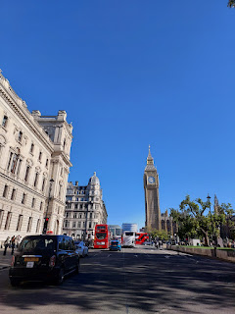

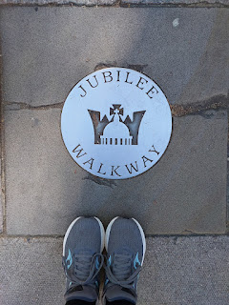

And we saw a beautiful memorial for Abraham Lincoln!!

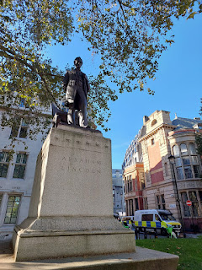

It seemed like we were constantly learning how the public transportation system worked in London. There is the Underground, but there are also other trains besides the Underground. Bus stations are nearby, too, and Google wasn't perfect in telling us which spot was the right spot to be in. Just when we thought we were getting the hang of how things worked, we had another slice of humble pie to eat and another learning experience to navigate through. Whenever we would eventually ask for assistance, we always got good advice, thankfully.

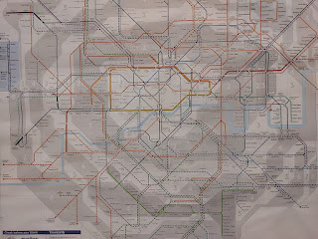

Weston, Abby and Amber on the Underground . . .

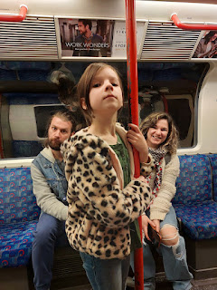

We found a place for lunch across the street from our next activity. The restaurant was called Boom Bap Burger and it was a fun place! The food was delicious and gave us a chance to rest our feet before doing some more walking.

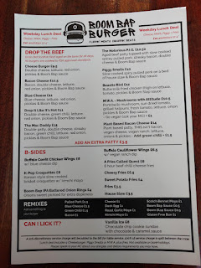

After our bellies were nice and full of burgers and fries, we walked across the street to the Young V&A Museum. It's a children's museum that was recently revamped, part of an endowment from Queen Victoria and Prince Albert, thus the V & A. In my research, I read that 22,000 children contributed to the renovations and creativity that went into what it is now. Wow!!

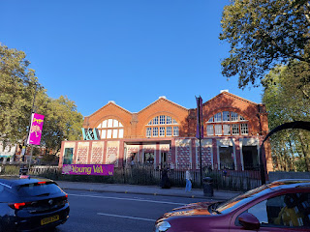

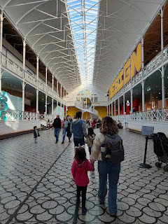

The first area we explored meant we needed to pass by the ABC area for the little ones. It was so cleverly put together! Talented older children created poems, rhymes, and riddles for each letter of the alphabet.

D is for Dress . . . (click to enlarge and read the accompanying note)

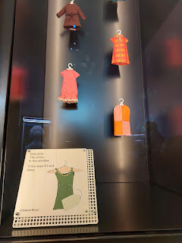

Sorry to jump around, but to our right was a beautiful spiral and mirrored staircase . . .

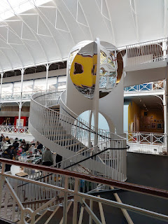

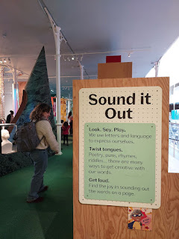

My favorite alphabet letter was "C" for Cat. (click photo to read the amusing play on words that a child wrote)

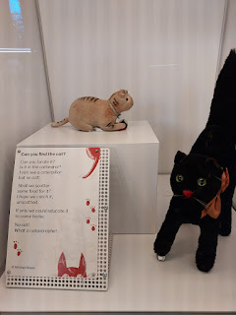

See if you can figure out this rhebus: (click to enlarge and keep in mind that this is Great Britain here)

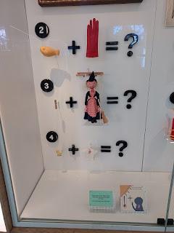

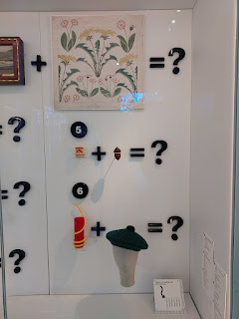

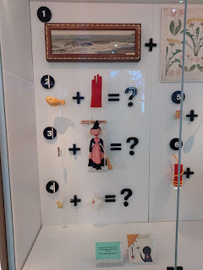

Answers will be shown below . . .

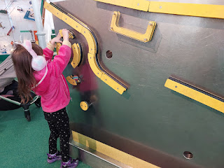

Video of Gwen learning to manipulate this magnet board to make things happen: (36 seconds)

https://photos.app.goo.gl/Qd2G1KSwAnV7yi2u7

Everything in the museum was designed BY children FOR children. Every little detail was taken into account.

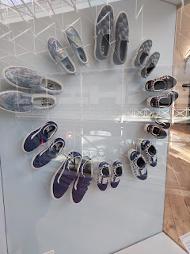

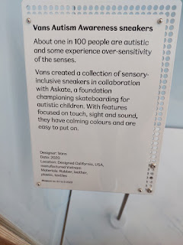

Amber found a wonderful video presentation upstairs and came to gather me and Gwen so we could see it with her. It showed several different scenarios of labors, tasks and processes that also have a similar counterpart. The film allows you to see how there are different ways of accomplishing a goal, and that as you do something that is creative and relaxing, it can also be a scientific process. The comparisons are shown side-by-side on the screen.

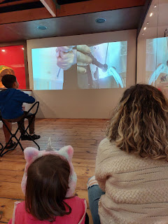

I will share a video link below of a portion of the movie that shows two people making something out of wood. The person on the left is using a lathe and larger equipment, while the person on the right is making a wooden spoon by hand. They are both sanding and shaping, but with different tools. The processes are equally satisfying and productive.

Video Link: (28 seconds)

https://photos.app.goo.gl/LNEmG4XxMDYSkg1M7

The Young V&A had a large upstairs area to create - whether on paper or in dress-up clothes performing in a small theater or otherwise. There was a beautiful staircase with mirrors that led to the upper floor, overlooking a food court area where many of the grownups gathered to visit while their children played.

Video showing the expanse of the museum: (10 seconds)

https://photos.app.goo.gl/wP8cQAgqfEa1XZTs6

This next photo was taken through a peephole, looking into a room with a slanted floor and with a trick of the eyes . . . Amber appears to be much smaller than her daughter, Abby . . .

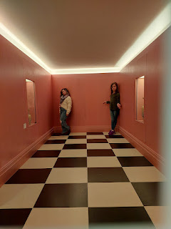

Video #1 of the trick room: (9 seconds)

https://photos.app.goo.gl/p1fC6TxKXDdBKLHKA

Video #2 of the trick room: (9 seconds)

https://photos.app.goo.gl/p4JARdYNYVjVcdMa6

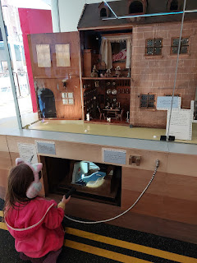

Above: Gwen is shining a flashlight into a model bomb shelter built underground, one that was used as an example to show what families had to do during WWII.

Below: A description of the apothecary shop (dollhouse) and why it was so important for Great Britains.

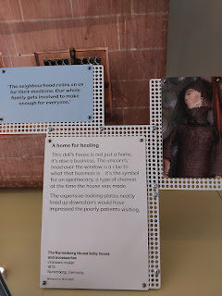

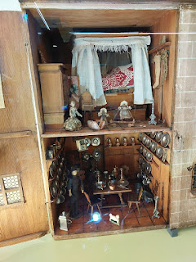

We let the girls play and explore for a couple hours, much to their delight. I failed to mention earlier, but the Young V&A is FREE to all who enter. What a wonderful gift!

Answers to the rhebus puzzles above:

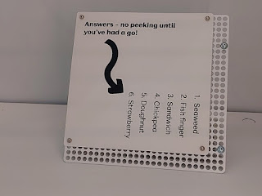

Amber really wanted a special family photo for their upcoming Christmas cards . . . some research was done and we found a blog listing several locations around London that included a picturesque red telephone booth with something swoon-worthy in the background. We passed by one of those spots earlier as we walked by Westminster Abbey, but the line for the photo op there was sooo long. So we went on the Underground to track down another one of the suggested locations.

Gwen made friends wherever we went. She would sometimes just start talking to a total stranger, but always one that she felt comfortable with. She'd tell them things like: "I'm almost 6 years old!" "Do you know what my reading level is? THIRD GRADE!!"

This lady was completely enthralled with Gwen and asked her several questions as we rode along . . .

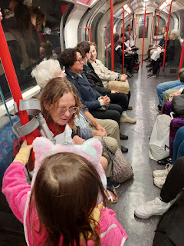

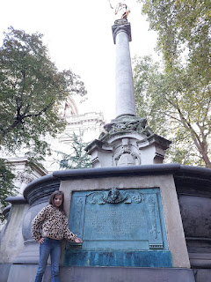

Near St. Paul's Cathedral, Weston scouted out a couple of good spots for their family photo. It took quite a bit of convincing for Gwen to agree to put on her designated sweater that coordinated with the rest of her family. I wasn't sure they would ever get her to put it on, but they managed to do it and I was quite impressed.

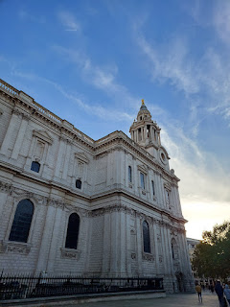

While Weston did the lap around the Cathedral to scout out the best spots, the girls decided that some dancing was needed in such a beautiful place. (16 seconds)

https://photos.app.goo.gl/YzfESQH9QpFQPsvg9

Unfortunately, I won't be sharing any of their family photos here, A) because I took the pics on Amber's phone, and B) it might ruin the surprise for their Christmas cards. But trust me, they are so cute!!

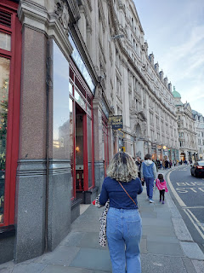

They offered to take a few photos of me at one of the locations we chose. It's always nice when you have someone you trust that offers to do it for you.

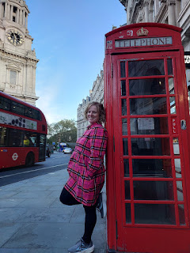

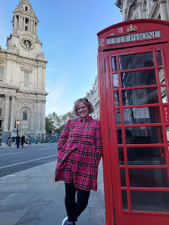

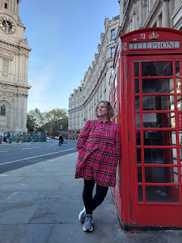

Monday, Oct. 16th:

Harry Potter Day!!! We got up and ready extra early to catch our trains and buses on time. It was a little over an hour to get to the Watford Junction area, northwest of London, where the Warner Bros. Studio resides. This is where all the Harry Potter movies were filmed and where all the props and sets still exist.

We found a really cute breakfast cafe around the corner from our hotel, with a mirror to watch yourself eat, ha ha.

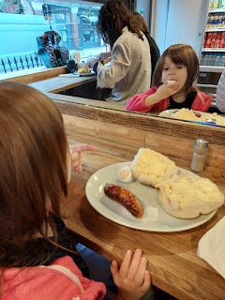

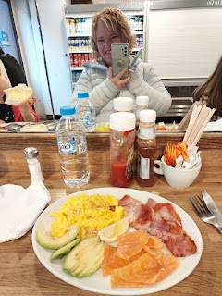

Once we arrived at the Watford train station, we found the area outside where the "Harry Potter Bus" came to pick us up.

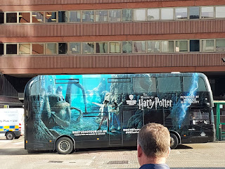

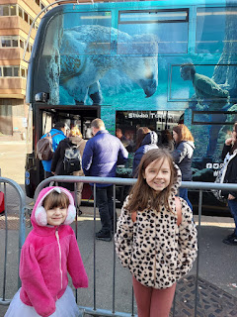

It was only about 15 minutes from there to get to the Warner Bros. Studio. Amber and her whole family could barely contain their excitement!! Amber has read all the HP books at least a dozen times, Abby has read them all through once, and Gwen has read through the first three. (Once we got back to Italy, Abby started reading the series again, finishing books 1 & 2 in just 3 days!)

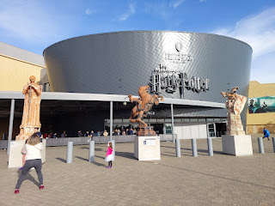

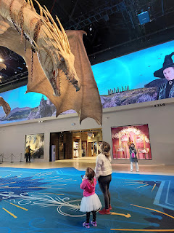

I had purchased our tickets several months ago, paying a little bit extra to include audio guides. I have learned (twice now - with Florence included) that audio guides are not meant for everyone, nor are they appropriate for every tour. In this case, having a digital guide hanging around your neck with lots of buttons to push (for games and activities to play), meant that you were not looking up or in front of you. For me, it was "information overload" within about 3 minutes. I took mine off, preferring to just use my eyes to discover everything around me. The Whitworths lasted longer than I did, but eventually they removed their audio guides as well.

We saw Harry's "cupboard - or room - under the stairs" . . . (from the first movie, The Sorcerer's Stone)

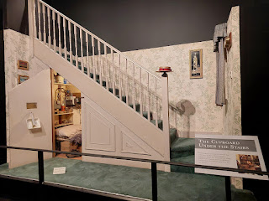

I particularly loved the Great Hall of Hogwarts! It was expertly arranged and decorated for Halloween, since it was, after all, October. :)

Video of the Great Hall, with 100 floating pumpkins overhead: (14 seconds)

https://photos.app.goo.gl/bHr3SUcSvpA4Zp4a9

The guide that we had during this first portion of the tour explained that some of the desserts were fake and a few were actually real. She encouraged us to try and spot the real ones . . .

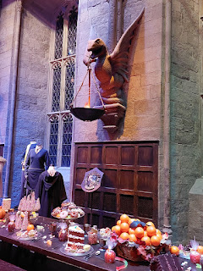

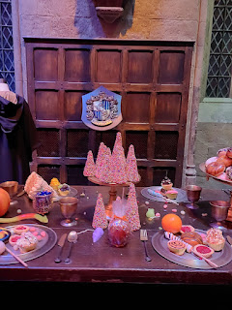

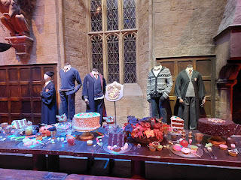

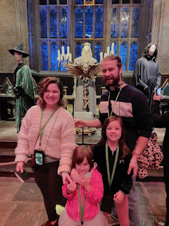

Video of some fairly recognizeable characters: (8 seconds)

https://photos.app.goo.gl/jj5ePSpgZvVKU3KE7

The next area helped us understand some of the background to the film production process, like costumes and makeup, etc.

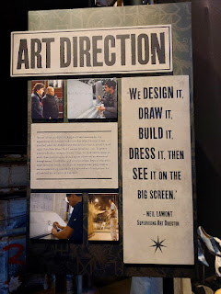

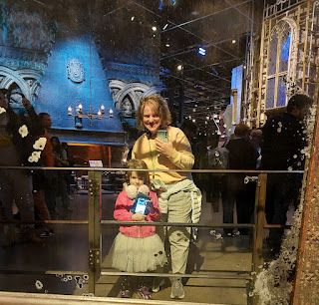

Video of some of the elaborate costumes that were used: (6 seconds)

https://photos.app.goo.gl/XiPDeNxpixRamafh8

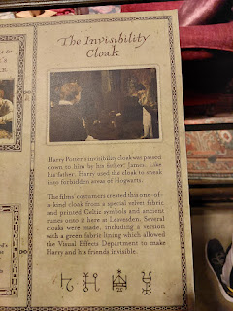

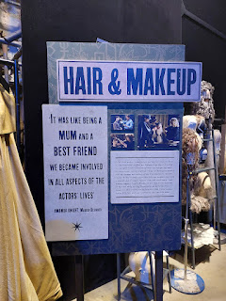

Video of some of the wigs that were worn: (8 seconds)

https://photos.app.goo.gl/DQNXznZjToQG1goa8

Video of the "moving staircase": (6 seconds)

https://photos.app.goo.gl/wfS7XeA3ngLqd4JX6

Something I had not considered before is that someone had to actually paint all the paintings that hung in the movie scenes. I wonder how many people they hired to do all of that . . .

Now I am not a Harry Potter super fan, and I didn't read any of the books, so I do not know the significance or the names of each thing we saw. But whether you are a super fan or not, you are welcome to just sit back and enjoy a simplified photo tour.

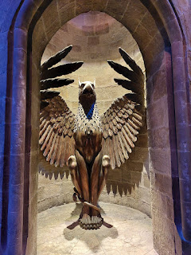

Some of the objects in Dumbledore's office . . .

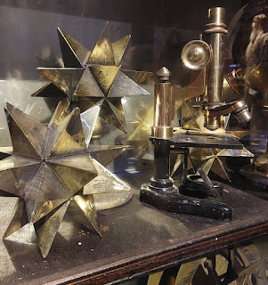

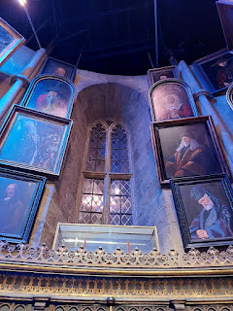

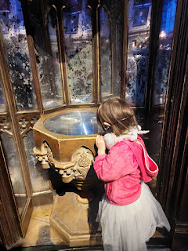

Video of the HUGE pendulum clock: (7 seconds)

https://photos.app.goo.gl/MDw11ZGPT2T1ebfN7

Video of Dumbledore's office: (15 seconds)

https://photos.app.goo.gl/8m7uVx1QqbYhibCw6

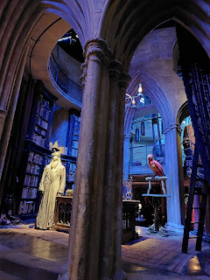

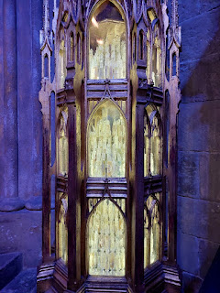

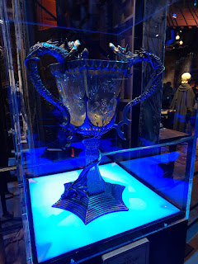

Next, we moved on to the Quidditch area, a fun sport that was played at Hogwarts and included skillfully riding a broomstick to catch the Golden Snitch.

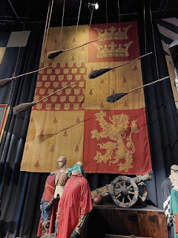

Video of Gwen commanding her broomstick "up": (8 seconds)

https://photos.app.goo.gl/AEwnhy4x1t8uLDW78

Abby shyly commanding her broomstick: (4 seconds)

https://photos.app.goo.gl/DNQ6nrK6YUeSLXeQ8

Amber gleefully commanding her broomstick: (5 seconds) (You can hear Abby's excitement too)

https://photos.app.goo.gl/bLBj28UUZPYkXTyPA

In the adjacent area, we were not allowed to take any photos or videos because they offered a fun service and they wanted you to pay extra for it. First they take a couple of photos with a green screen behind you (our background would say "WANTED"), and then they put you on a moving broomstick with a green screen in the background. They tell you to wave, or lean forward, or tilt left and right, and to give yourself a fist pumping cheer at the end. They put it all together as a mini movie of you in a quidditch match, chasing the Golden Snitch and being crowned as champion at the end. It was a bit pricy when you have 2 children who participated, but Amber and Weston opted to just purchase a photo of each girl on their broomstick (for about 10 pounds each). The girls were sad that we walked away from the cool videos that were made, but we still had so much more to see and do!!

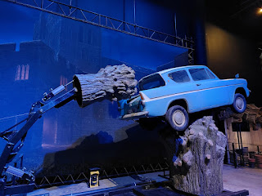

Gwen loved all the creepy stuff, especially all the snakes and giant spiders . . .

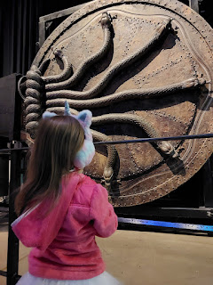

We had her pose for a photo in front of the Death Eaters, and then I showed her the two pictures I took. She liked the first one best, getting a kick out of her sweet innocent smile while they looked so scary and menacing over her shoulder.

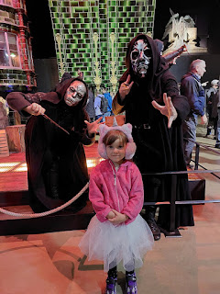

In this one, we told her to act scared, but she told us afterwards that she wasn't scared at all!

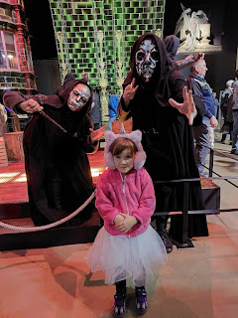

Sometimes the Death Eaters would randomly do a performance right in the studio near where we stood. I got a good video one of those times: (34 seconds)

https://photos.app.goo.gl/5mV2GgLDjGpe9z318

Gwen waved her hand to magically chop some carrots: (14 seconds)

https://photos.app.goo.gl/8Tffuh1zbUjfjje58

And then she magically got the scarf to knit itself: (17 seconds)

https://photos.app.goo.gl/4C3QgW1sbZzM9ifb7

Next, we entered the Dark Forest where we encountered huge spiders and Buck Beak, a beautiful and majestic white bird.

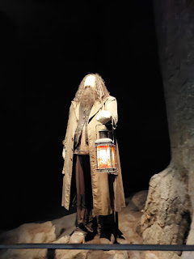

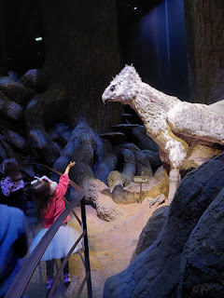

Video of the girls reaching out to Buck Beak. They later learned that if you bow down to him, he will likewise bow to you. (8 seconds)

https://photos.app.goo.gl/3spMTpVaM7hqWdWw8

Sorry this photo is blurry (because it was so dark), but it was so cute to see Gwen holding Weston's hand, even though she wasn't scared at all. She had a giant smile on her face the whole time, ha ha.

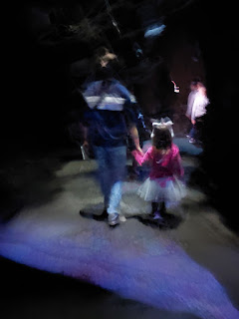

Next, we arrived at the famous train, Hogwarts Express. Amber said this was her favorite set of all, and that it gave her tingly goosebumps as she came around the corner and THERE IT WAS.

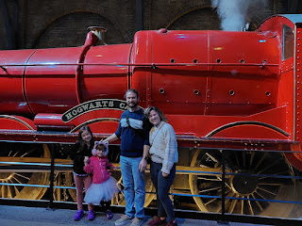

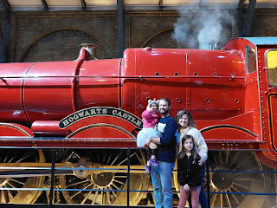

Video of Abby, Gwen and Amber boarding the train: (11 seconds)

https://photos.app.goo.gl/GQ4DBAeLVBRsiwyCA

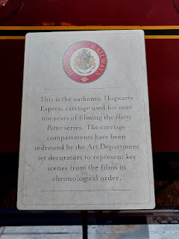

"This is the authentic Hogwarts Express carriage used for over ten years of filming the Harry Potter series. The carriage compartments have been redressed by the Art Department set decorators to represent key scenes from the films in chronological order."

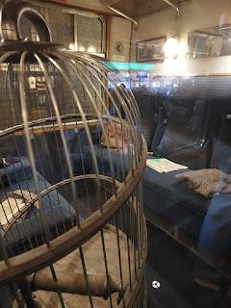

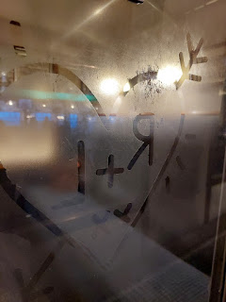

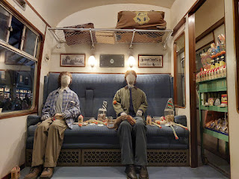

And a trip to the set of Harry Potter wouldn't be complete if you didn't get to push your luggage cart through the wall at Platform 9 3/4 . . .

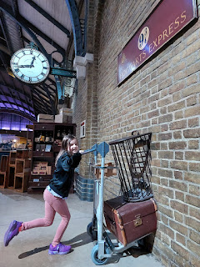

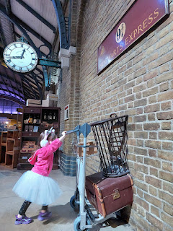

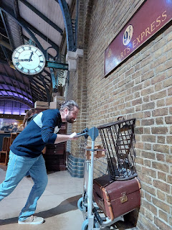

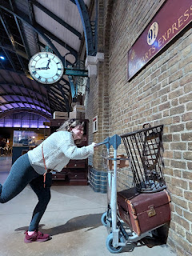

We finally made it to the food court midway through the tour! We bought some loaded fries and some famous Harry Potter Butter Beer to fill our empty tanks. Yummy!

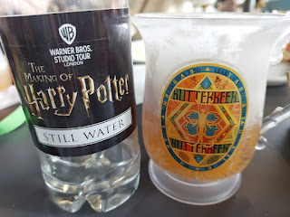

There were several things to see outside near our picnic table, including the house where Harry lived with his horrible aunt, uncle and cousin.

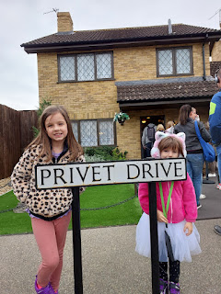

They didn't want Harry to attend Hogwarts School of Wizardry, so each time an invitation arrived in the mail (via Dumbledore's snow owl), they would tear it up. Pretty soon, hundreds of invitations arrived, spooking everyone except Harry, who was pleased and in awe of the spectacle.

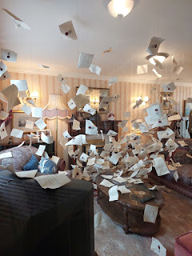

Video of the living room inside the house: (5 seconds)

https://photos.app.goo.gl/J4pTTx1oJ5ssgUVdA

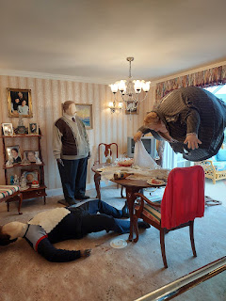

Harry, getting a visit from Dobby (a house elf) in the second film, "Chamber of Secrets".

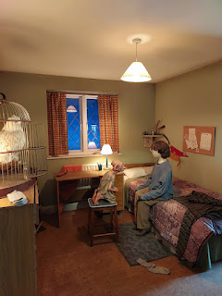

More acting and hanging on for dear life to the triple-decker Knight Bus . . .

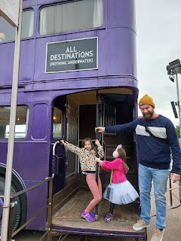

The ACTUAL wooden bridge of Hogwarts Castle . . .

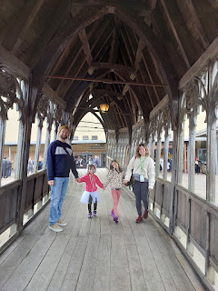

The famed flying car from the scene with Harry and Ronald Weasley, only this time it's Abby and Gwen!!

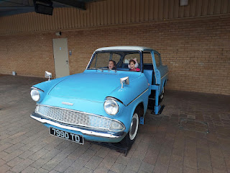

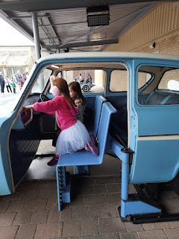

The Greenhouse with the screaming Mandrake plants . . .

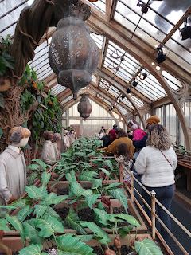

Video of me lifting one out: (4 seconds)

https://photos.app.goo.gl/ARiQsBeJeZRtLbPN7

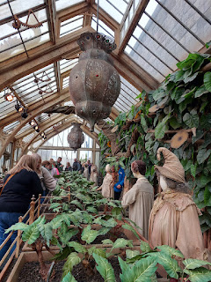

In the next building were some of the hideous creatures from Harry Potter and their makings: (11 seconds)

https://photos.app.goo.gl/FTQQcYHrZGxGPYBs7

Video of Amber and Gwen controlling Dobby's movements through a computer: (10 seconds)

https://photos.app.goo.gl/LM4hEVwT9M6DCrsDA

Buck Beak: (9 seconds)

https://photos.app.goo.gl/4ZBKsxztVsnQ8CnZ6

Entering Gringotts Bank near Daigon Alley: (10 seconds)

https://photos.app.goo.gl/6tyCJkCr4kXP2rN97

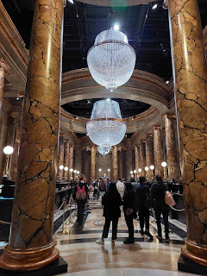

Harry's Invisibility Cloak . . .

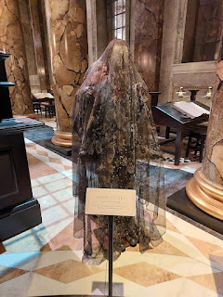

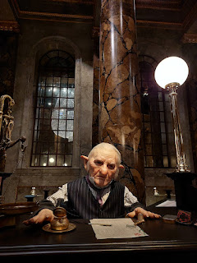

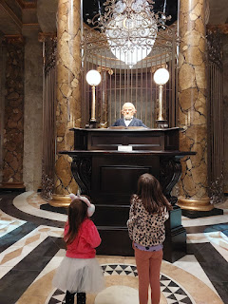

A magnificent treasure vault . . .

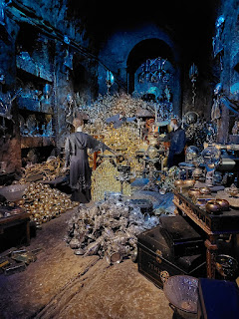

Abby protecting the treasure . . .

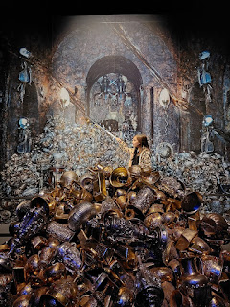

A reenactment of a dragon invading Gringotts Bank: (48 seconds) *wait for it*

https://photos.app.goo.gl/1NxoJ94dcN2LQBgZ9

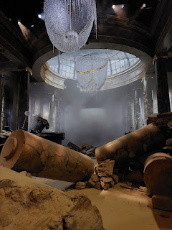

Next up: Daigon Alley, with all of its shops and apothecaries.

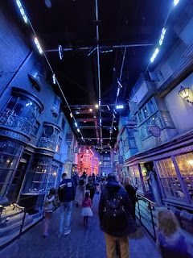

Explosion in Ollivander's Wand Shop: (27 seconds)

https://photos.app.goo.gl/MkaaXTASjKpyiabN6

The last area (and most beautiful) was the model of Hogwarts Castle. It was used for several scenes, with computer generation to enhance each scene, whether it was day or night, mystical and full of doom and gloom, or a magical wintry wonderland.

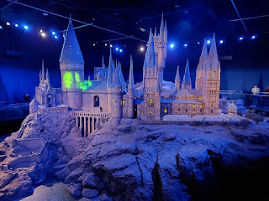

Brief sweeping view of Hogwarts: (5 seconds)

https://photos.app.goo.gl/Zwpo8tHWWisGkGiy8

(Click the photo below to learn some interesting facts about the Castle)

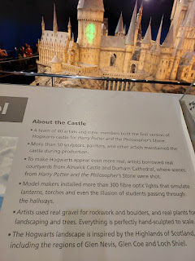

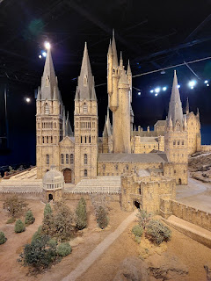

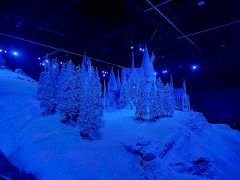

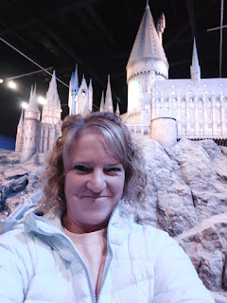

Amber, Abby, Gwen and Weston - having the time of their life!

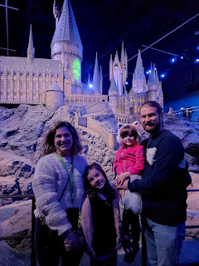

As we entered the gift shop, it was immediately apparent that some wizarding wands were available for purchase: (9 seconds) HOLY MOLY

https://photos.app.goo.gl/8248qD2YuVSoWcWb6

Too bad this chess set was 300 pounds ($$).

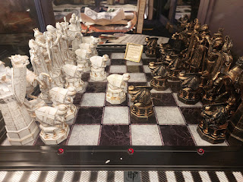

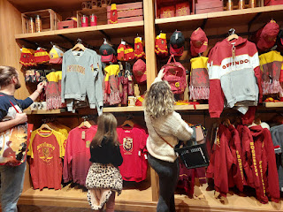

We each left with something special from the gift shop: a chocolate frog, wands, stuffed animal keychains, books, magnets, and some disgusting jelly beans, ha ha. When I was reading some blogs and researching ahead of this trip, most people said to expect to spend about 3-4 hours at the WB Studio. Well, we ended up spending the entire day!! We arrived at 10:00 a.m. and we didn't leave until about 4:00. Exhausted, but fulfilled.

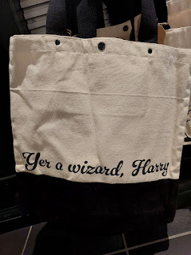

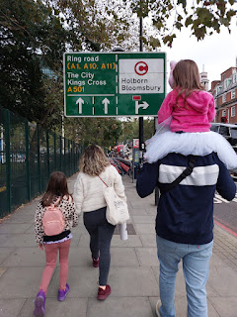

Walking from the Victoria Station back to our hotel, I noticed this building plaque for the first time. Apparently, Charles Dickens used to live right around the corner from where we were staying!

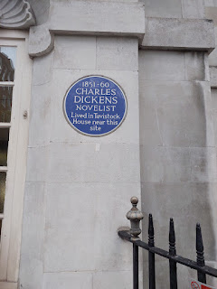

We finally had our fish & chips for dinner, something Abby was really looking forward to.

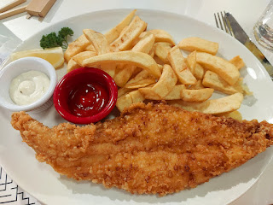

We had one more stop to squeeze in on our last night: a walk across Tower Bridge.

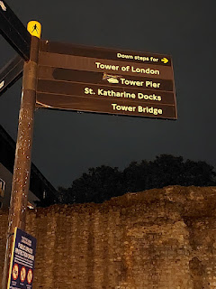

Tower of London behind the fam . . .

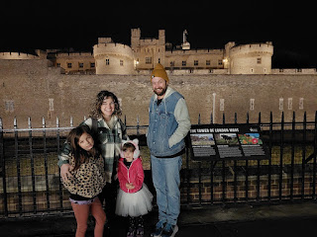

Gwen, Me, and Abby. How fun to be here with Amber and her family!

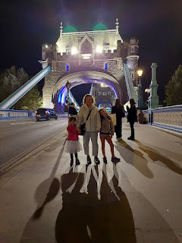

The last time I was here was in September 2018 with my sister, Charmaine.

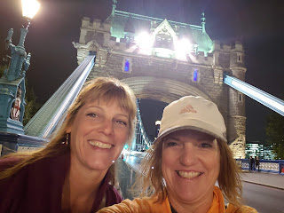

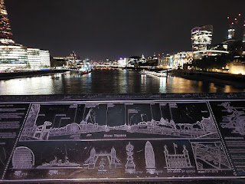

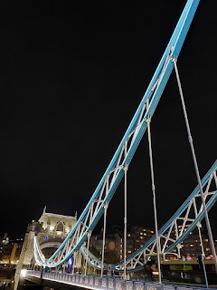

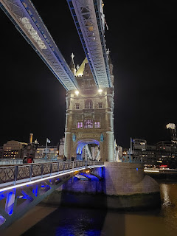

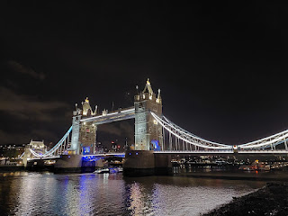

We walked all the way across and then along the south side of the river for a bit, until we FINALLY found the correct bus stop to get us back to our hotel. We tucked ourselves in around 10:00 p.m.

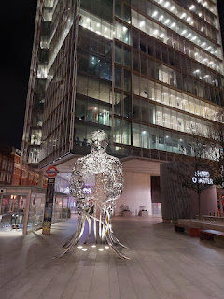

Tuesday, Oct. 17th:

We brought all of our luggage downstairs to a storage closet in the hotel, which was fantastic so we didn't have to haul it all over town with us before heading to the airport later that afternoon. After a short breakfast stop, we headed south by bus and train to do some family history sightseeing close to the Tower Bridge and the River Thames.

*Gwen's mischievous grin . . .

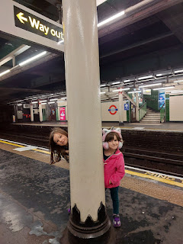

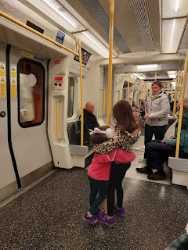

First stop:

All Hallows by the Tower Church, the oldest church in London. This is where my 13th great grandparents, Nicholas Lanier and Lucretia Bassano, were married. Lucretia's father, Anthony Bassano, and his 2nd wife, Ellen, are also buried here.

Me with Gwennie outside the church . . .

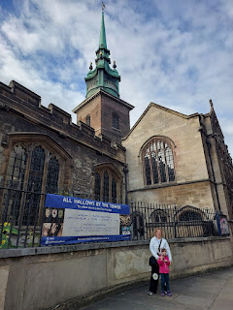

Amber, Gwen, Abby and Weston in the entrance . . .

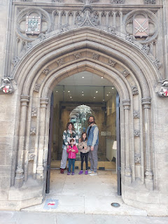

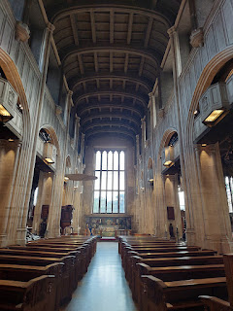

Video inside the main chapel: (14 seconds)

https://photos.app.goo.gl/53kZJ83GGFQVXFe18

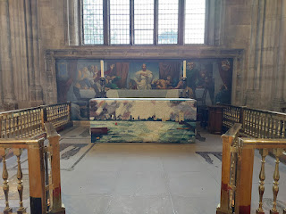

I remembered a plaque on the wall in the corner of the chapel from my visit in 2018 with Charmaine, and I walked right over to it. It's a tribute to Margaret Bassano, a close cousin to Lucretia Bassano.

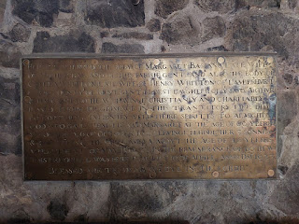

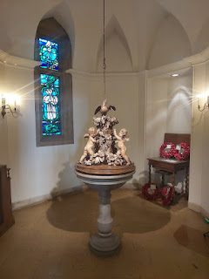

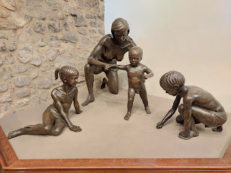

We went down into the crypt underneath the church, where there is a sort of museum that houses artifacts from centuries long ago. They include the following:

Marriage record for John Quincy Adams and Louisa Catherine Johnson, married in this same church in the year 1797. (note the small white paper with an arrow in the photo below)

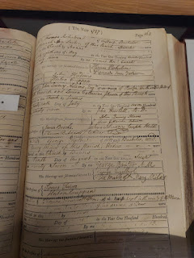

More info about their marriage. (click on photo to enlarge)

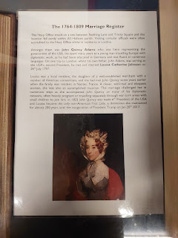

Baptismal record for William Penn Sr. in this very church. His son, William Penn Jr., was also baptized here and later became the founder of Pennsylvania.

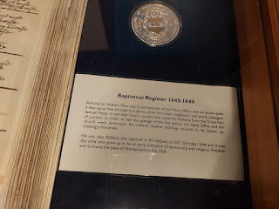

I think the photo below is supposed to show the original baptismal record of William Penn, but the white paper with an arrow doesn't seem to be pointing to anything . . .

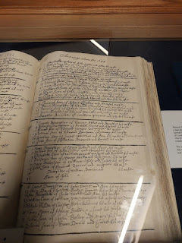

An original drawing of William Penn Jr. in 1666.

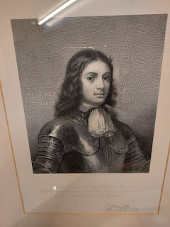

A memorial plaque in honor of William Penn Jr.

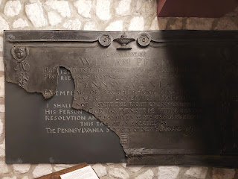

I especially loved this next paper, with a beautiful acknowledgement of slavery: (click photo to enlarge)

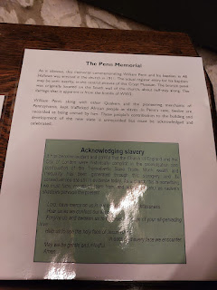

A live, open air painting of All Hallows on 30 December 1940. (click to enlarge and discover more)

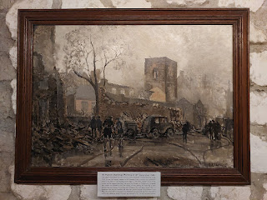

An engraving of All Hallows in 1736. (click photo to enlarge details and read the summary)

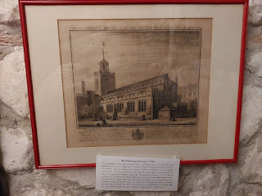

A 1941 sketch of the immense damage done to All Hallows during WWII. (click photo to read more)

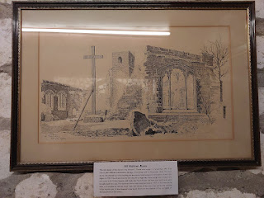

An explanation of an ancient chapel and crypt in All Hallows, dating back to circa 1280 AD. (click photo to enlarge)

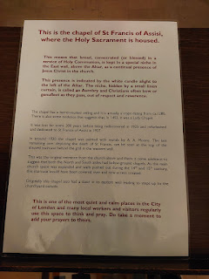

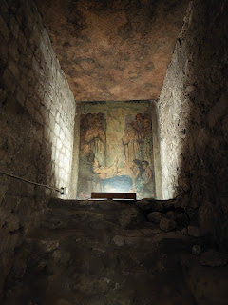

An explanation of the ancient Peacock Pluteus Stone found in the crypt below All Hallows. (click photo to enlarge)

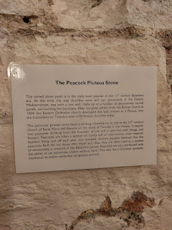

A beautiful chapel, with a quiet and peaceful feeling here.

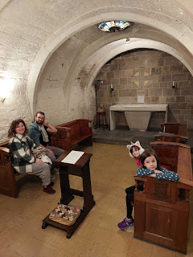

And then, next door to that first chapel of St. Francis is a second chapel. This is where I felt something significant back in 2018. I felt it again on this second visit. Both times I was moved to tears. I'm not sure why I felt what I felt, but there was a definite connection to this tiny little underground crypt. I hope to discover the answer someday.

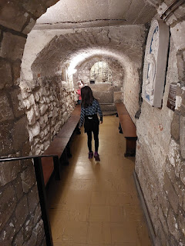

This special little chapel is called St. Clare Chapel. (click photo to read more)

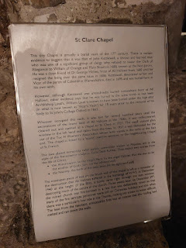

Some of the poignant elements of St. Clares Chapel . . .

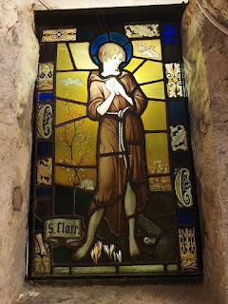

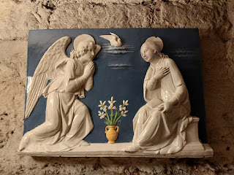

The little connecting window to the St. Francis Chapel next door . . .

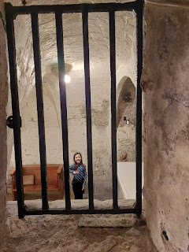

Me, standing in this very special place, with tears in my eyes and a fiery warmth in my heart.

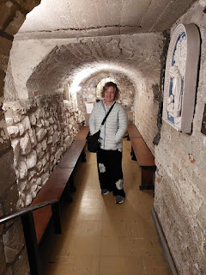

Back upstairs in the main chapel, I noted all of the crocheted pillows hanging underneath the pews. I don't know if they are used as seat cushions or kneeling pads, but each one is distinct and special, and is personalized with family and ancestral references.

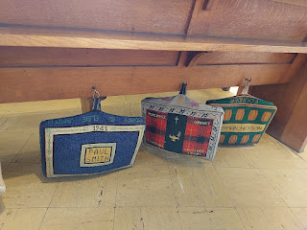

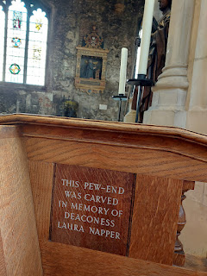

Do you get it? Laura NAPPER . . . LOL

Before we left, I noticed some helpful history posters for All Hallows by the Tower. (click images to enlarge)

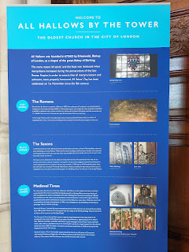

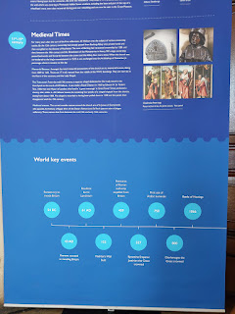

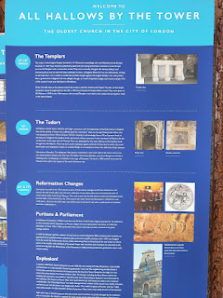

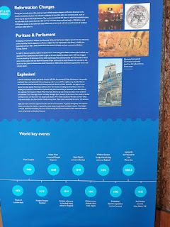

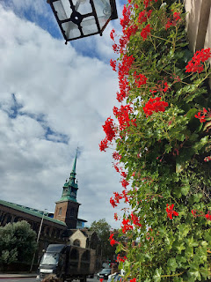

As we left All Hallows to head to our next family history location, we had to cross the street at the nearest crosswalk, which allowed us to see the church from a good vantage point.

Video of All Hallows as we passed by: (9 seconds)

https://photos.app.goo.gl/VTnXSPmgmTEudXxt6

Second Stop:

I intended to take us to see Mark Lane (a Bassano neighborhood), but I didn't expect to pass right by St. Olave's Church on the way! What a happy surprise . . .

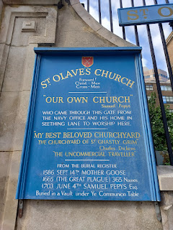

My 13th great grandfather, Nicholas Lanier, lived in this parish (a church jurisdictional area) when he moved from Rouen, France to London in the late 1500s. (approx 1561) His father, John Jerome Lanier (1499-1572), is buried here.

Click photo below to read a little background for St. Olave's . . .

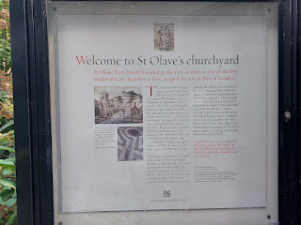

Brief video entering the back garden area: (6 seconds)

https://photos.app.goo.gl/fEWeX7w1aGD6HD3H6

The adorable back door to the church, open and welcoming us to enter . . .

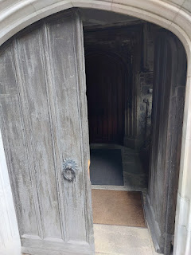

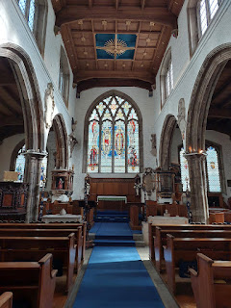

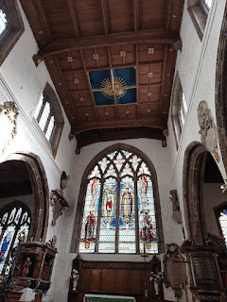

Video of the chapel: (15 seconds)

https://photos.app.goo.gl/e9835r3xabGxwmwaA

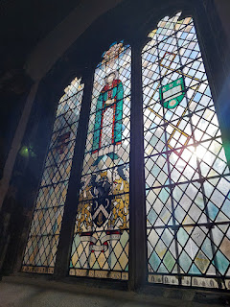

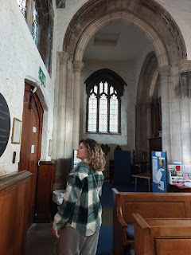

A statue to memorialize Sir Andrew Riccard, who died here in 1672, which would have potentially been in the same time frame (though slightly later) as some of my Bassano and Lanier ancestors. I wonder if their paths ever crossed . . .

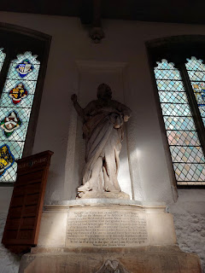

This is the same piano where James, a homeless man, sat and played beautiful music when Charmaine and I first entered St. Olave's in 2018. On this day, however, it sat covered and quiet.

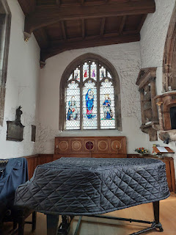

Video of James at the piano in 2018: (31 seconds)

https://photos.app.goo.gl/ref851evr6wi8qsg8

I also found a little history of Nicholas Lanier in my Google Drive: (*Note: I have seen both Lucreece and Lucretia Bassano listed as his wife's name)

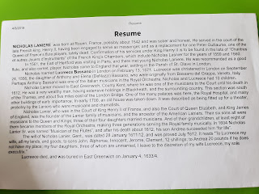

A list of the Rectors who have served in St. Olave's Parish since 1319. While I didn't recognize any of the names, some would have certainly served here when my ancestors attended services in this church.

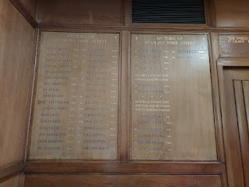

An old plaque honoring someone from 1619 . . .

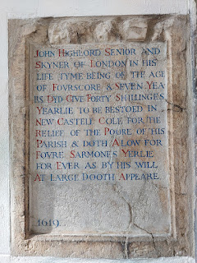

A sign next to the front door as we exited . . .

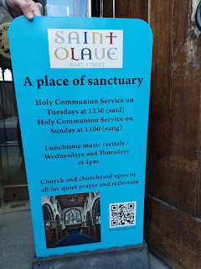

Third Stop:

Just around the corner from St. Olave's is Mark Lane. There is an ancient Bell Tower on the corner of Mark Lane and Dunster Court, dating back to the 12th or 13th century. I have seen a reference online to the Bassano brothers being granted property, known as the "Bell", in roughly 1572. The area of Mark Lane and this Bell Tower is within spitting distance of Seething Lane, Hart Street, and St. Olave's Parish.

Link to an article that references the Bassanos and their connection to the "Bell":

https://www.british-history.ac.uk/survey-london/vol15/pt2/pp18-20

Pay particular attention to the paragraph that is entitled "(C): The house of John Bacon". (near the end of that paragraph)

Today, that old Bell Tower is undergoing some significant renovations. You cannot get close to it at all, because it is surrounded by barriers. (Barely distinguishable in the photo below)

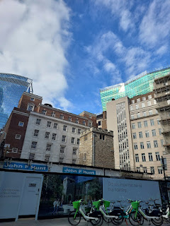

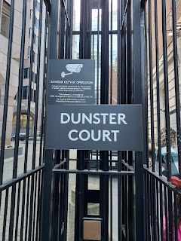

Sort of an explanation of what the plans are for the site . . .

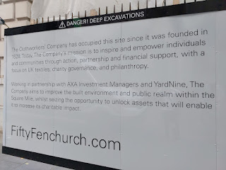

Along one side of the fenced off area surrounding the Tower, there is a helpful timeline of its history.

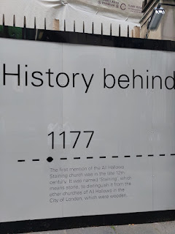

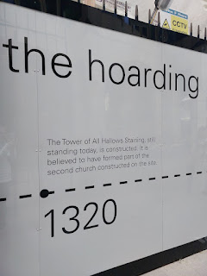

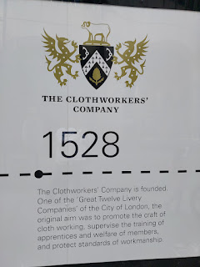

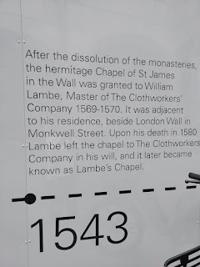

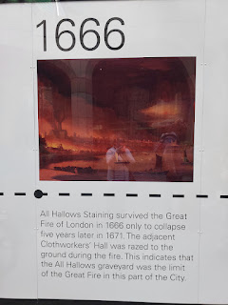

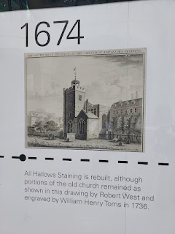

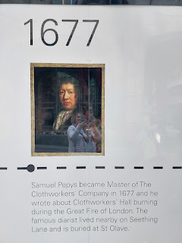

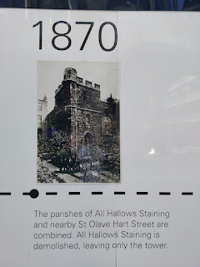

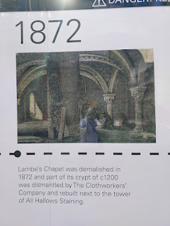

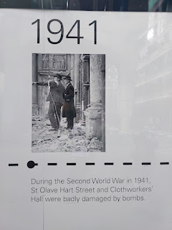

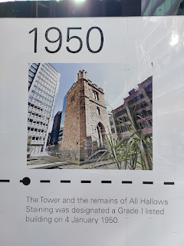

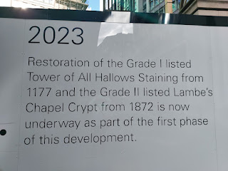

A photo on the wall of what it will look like eventually?

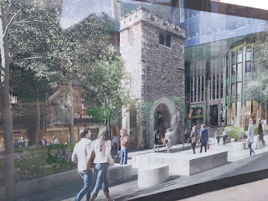

This was the conclusion of our family history tour in London. Now we needed to hustle back up to our hotel, grab our luggage, get a quick bite to eat, and hurry even further north to Stansted Airport. Little did we know, there would be a horrible night ahead . . .

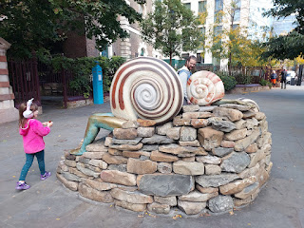

Airport Timeline:

2:30 p.m.: We arrived at the airport 2 hours ahead, as per the written recommendation from the airline. (RyanAir)

3:55 p.m.: We finally make it up to the check-in counter to get boarding passes and drop off our luggage, after standing in line for 90 minutes.

4:15 p.m.: We are scrambling to get through security, even though our tickets say that our gate closed at 4:10. We are not given any priority at any point thus far, even though we are in the right places and doing all the steps required of us.

4:25 p.m.: We arrive at our gate, completely out of breath from running nonstop through the airport for an eternity. I was on the verge of an asthma attack as well . . . Our gate is closed and there is no one in sight, even though our plane is still parked outside the window.

I collect my breath and my wits and dash over to a nearby gate to ask for assistance from a girl working there. She tells me there is nothing they can do. We have missed our flight and now we have to go back, collect our luggage and start over. Seriously??

Dejectedly, we follow her instructions and work our way back to where Customer Service is located, on the opposite side of where we stood in line for almost 90 minutes earlier to check our bags in.

The girls are tired, thirsty, hungry, and we haven't had a potty stop in a while. Weston suggests that I take the lead when we get to the front of the line. I gratefully accept.

The CS lady clearly did not like her job, based on her body language and facial expressions and lack of eye contact with us. She went through her standard protocol, and basically told us that because we missed our flight, we now had to pay a 100 L (L = pounds) fee per person (approx $125 USD EACH).

I asked if we could speak to a supervisor. Enter Mr. Zero Sympathy. I told him how we arrived 2 hours ahead and that there was no efficiency in their check in process. He put all the blame on us. I told him to check the security cameras to see that we arrived in a timely fashion. He did not care. He said we should have asked for more help so we didn't miss our flight. There was nobody to help us until we got to the front of the line, and by then it was too late! But, according to him, it was all our fault. Not once did we get any sort of apology.

He had the lady (pretend to) look up to see how many people made the flight and how many missed the flight. He lied and said that we were the only ones who missed the flight, when we knew of about 10 others who also missed the flight. We even saw him "help" a young family who was ahead of us in line, but he denied any recollection of that conversation.

They lied again by saying that there was a flight heading out first thing in the morning and there were only 5 seats left. We did end up on that flight and noted that there were several empty seats . . .

They lied again by saying repeatedly that because we had purchased the Family Plan (which enables us to sit together because we have small children), the cabin crew on board would be the ones to rearrange passengers so that we could have seats next to the girls. She told us that no one else could do this; ONLY the crew on board. But that didn't happen either. They made US figure it out for ourselves with zero help from them.

I was pretty mad at this point, but I didn't want to blow my top. When I needed to, I just stood there, silently stewing long enough to make them uncomfortable on the other side of the counter. She gave me a paper with the information I needed in order to file a written complaint. We paid the roughly $125 per person and finished up by getting those "last" 5 tickets on the 6:30 a.m. flight.

And then we settled into the airport until the next morning.

I called Scott and told him all the disgusting details through my angry tears. He was amazingly calm and supportive, which was just what I needed. Then we found a table and a couple of benches in the food court area, and finally got some dinner - which was surprisingly delicious and very affordable.

A short time later, I saw a girl (20-something) a few tables over who looked very upset. She appeared to be crying and mumbling to herself in frustration. I told Scott I would call him back and then I walked over to her. I said, "Are you okay?" She was speaking with a thick accent that I couldn't distinguish through her tears. I asked if I could give her a hug, to which she accepted. I learned that she, too, had missed a flight, and had been poorly treated as well. She now needed to catch a bus down to Cornwall, but she didn't know where to go and was all alone to try to manage way too much luggage by herself. When I asked how could I help, she indicated that she needed help carrying her luggage. She had 2 heavy and poorly maneuverable suitcases, plus a weird shaped and saran-wrapped bag that was incredibly heavy and awkward, with only a makeshift saran-wrap handle to carry it.

I told her that everything would be okay and that I would help her get to where she needed to go. I let Weston know what I was doing and made sure I had my phone with me. We had to ask 3 times along the way to make sure we were going in the right direction, but we received a lot of kindness each time. We made it to the bus ticket office outside the airport, where she purchased her one-way ticket and got into the correct line to wait. She was so grateful for my help, and I was so happy to give it. It gave me something better to do than to just focus on all my anger and frustration with RyanAir.

Her name is Beatrice and she is originally from Southern Italy. She currently lives in Cornwall with her boyfriend. Her bus trip would be about 11 hours that night (blech), but at least he would meet her at the other end.

I gave her lots of hugs before we parted ways.

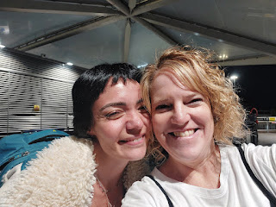

Back in our food court area, Weston was playing Uno Flip with Abby and Gwen, while I sat at the next table over to work on my blog.

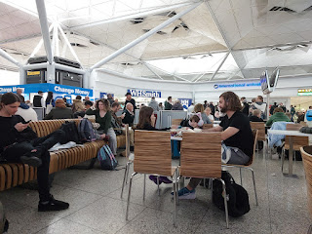

Throughout the long night in the airport, we made do with the little we had. There was only one set of bathrooms to access, since the rest of the airport had been closed off. The one drinking fountain was broken and the bathroom sinks had signs indicating that the water was not safe to drink in there, either. Our only option was to buy bottled water from the shops in the food court.

Weston and I checked all the big suitcases back in around 7:00 p.m. for what they called, "Twilight check-in". While we didn't have any toothbrushes to freshen up with, at least we didn't have to stand in any more long lines once the morning came.

The girls napped for a couple of hours on the benches, which was nice. The grownups stayed up the whole night . . .

One of the ways we passed the time was to make some new friends and have interesting conversations together. We met Carlos from Costa Rica, who was very intelligent and multi-lingual. He is 46 years old, single, used to work for Equifax (USA) but is now pursuing a doctorate degree in business. He has family in Germany and England, and also missed his flight. His plane coming in was late, which was completely out of his control. He loves hiking and anything outdoors, so we had fun swapping photos and stories about our recent adventures. He was very interested in Amber's artwork, which led to us all exchanging Instagram account info with each other. He was a very chill guy and a great conversationalist.

We also met Sarah and her 11 year old daughter, Vigga (Vee-gah), from Copenhagen, Denmark. They had flown in to see all the Harry Potter stuff at WB Studios, just like we did the day before. Vigga was so darling! She has her own YouTube channel and loves to be in the spotlight. She and Abby really hit it off and ended up swapping info to stay in touch as Pen Pals!! We enjoyed a lively conversation as Sarah joined our small group. She is very witty and was fabulous in entertaining all 3 girls with guessing games and pretend play.

Sarah, Vigga, Abby, Weston, and Amber . . .

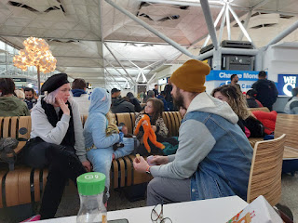

At 3:00 a.m., when the security area opened back up, we all stuck together until it was time to head to our respective gates. Making new friends certainly helped the time pass more quickly during that long night.

Wednesday, Oct. 18th:

We had no issues with the new flight, with the exception of us having to figure out a way to sit closer together on the plane, since the cabin crew refused to help us. As they closed the plane door, and having already noted that there were SEVERAL open seats around me, I hunted Weston and Abby down at the back of the plane and had them move up to sit by me. So much for the validity of the customer service agent who told us, "These are the LAST five seats available on this flight" . . .

Our new signature phrase is: "Thanks RyanAir."

Thanks for a super slow check-in process that makes people miss their flight.

Thanks for blaming everything on us.

Thanks for making us miss a whole day of fun back in Italy as we made our way home a day late.

And thanks for making us pay out the wazoo for the whole experience.

I am working on my email to them, to plead our case and see if I can get a refund for the "missed flight fees". Not a fun process, but a very necessary one.

The sunrise was admittedly beautiful as we left England. (Thanks RyanAir)

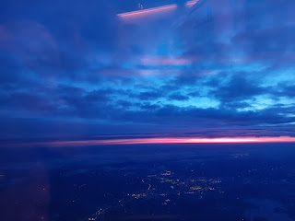

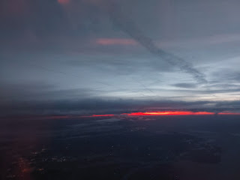

Zoom in on this third photo to see the little patch of fiery red that looked like a lava puddle on top of the clouds . . .

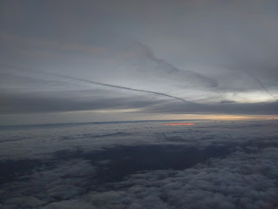

This is how I felt after being up all night . . . deer in the headlights + zombie . . .

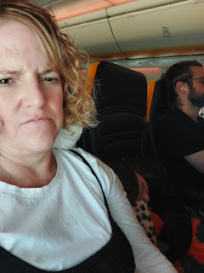

But seeing sweet little Abby sleeping next to me, I scrounged up one last feeble smile.

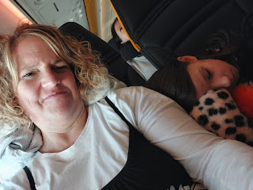

Welcome back to Venice, Italy!! Hooray - we finally made it.

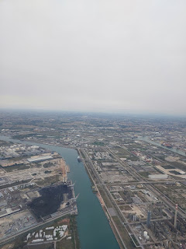

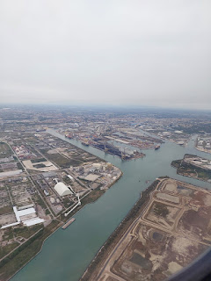

Scott picked us up in phases, since we couldn't all fit into our little car. We loaded the girls in first, plus all the bags that could fit. He drove Amber and Weston to the train station (Venice Mestre) so they could ride back to Vicenza, while I waited at the airport with the rest of the luggage. Then he came back to pick me up and to squeeze the last duffel into the back seat in between the girls. It served well as a place for them to lay their heads during the 45 minute drive home. Once the girls and I were in the house with all the gear, Scott drove to the Vicenza station to pick up Amber and Weston. And then he went to work for the day. :)

What a tired mess we all were. I got maybe a one hour nap, which helped me limp through the rest of the hours until bedtime. Amber baked Gwen's birthday cake for the following day, and we also made a video call to Scott's dad, Phil, to sing happy birthday to him. He is now 92 years old!!

As I said earlier, even though our London trip ended on a really sour note, it did not change the overall fun that we had.

Last but not least . . .

Here are a couple of darling photos of Avery. (I can't remember if I already shared the first one or not) She sure is growing up!! I still haven't seen her since July, but I am hoping to see her within the next week.

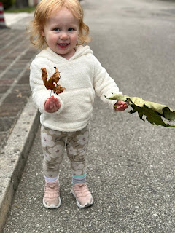

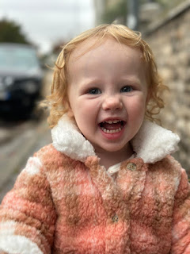

Jack has been enjoying some farm experiences in Minnesota.

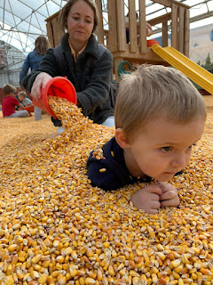

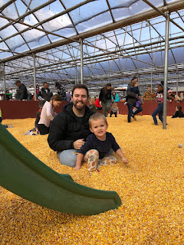

Video of Jack feeding a baby cow: (14 seconds)

https://photos.app.goo.gl/Q7bfmxFxbjUDPFCf7

And he's also been learning to play T-ball!! Zoom in to see the look of pure joy (and mischief) on his face at the top of the stairs, ha ha . . .

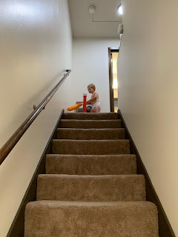

I couldn't resist one last photo (or two) of my baby brother, Michael, holding some of their new baby chicks up in Northern Idaho.

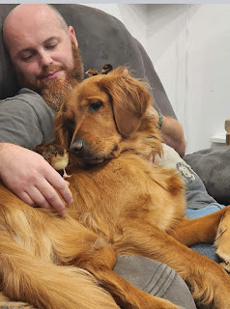

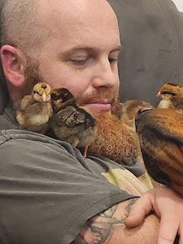

You're welcome. And have a wonderful week!! :)